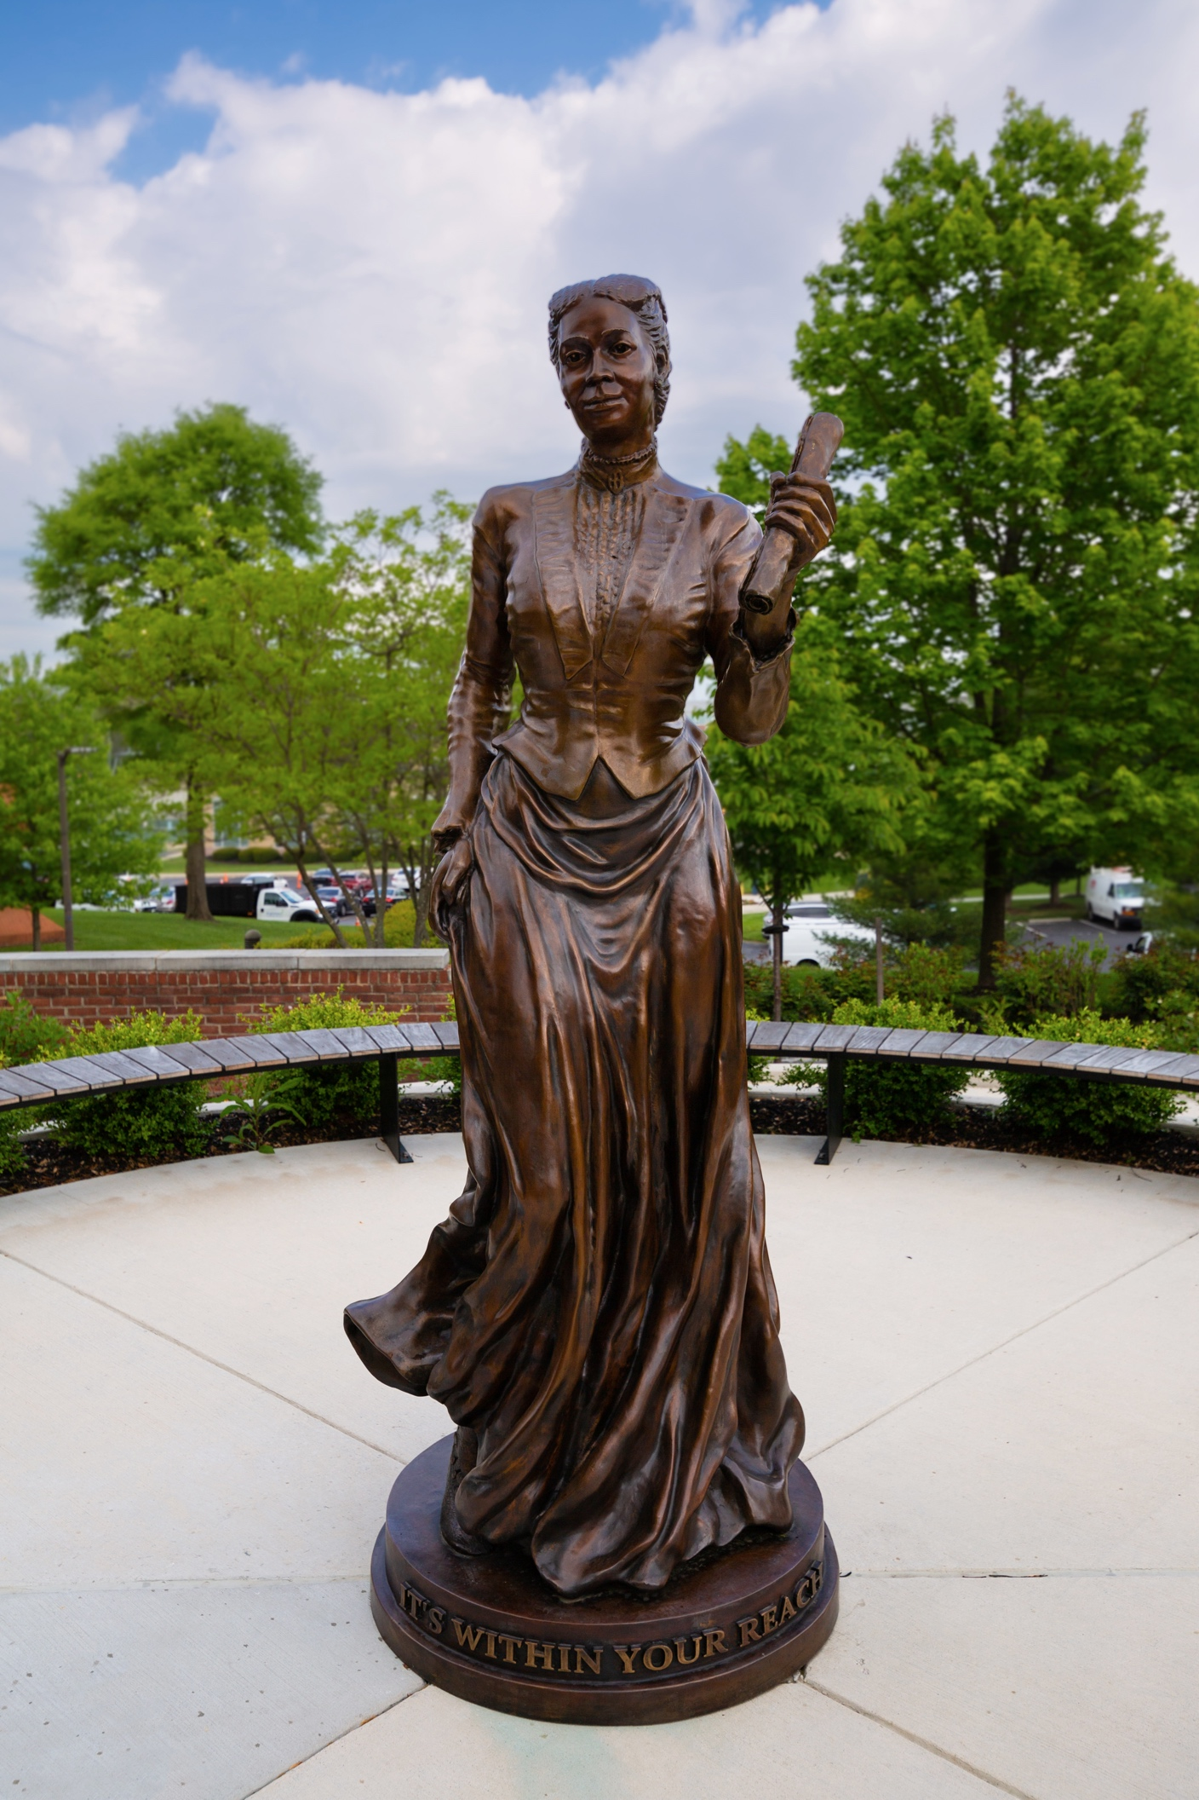
Fanny Jackson Coppin Statue
Greetings from the President
________________________________________________________________________
Dear Coppin State University Graduates
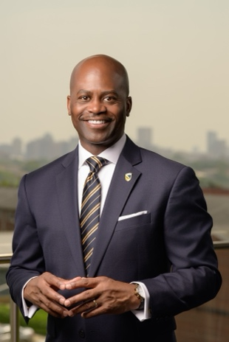
Today marks the culmination of your hard work, perseverance, and unwavering commitment to excellence. On behalf of the entire Coppin State University family, I am honored to celebrate this momentous occasion with you and your loved ones.
When you first arrived at Coppin, you embarked on a journey that would foster your growth, strengthen your self-efficacy, and ultimately transform you. You have risen to meet every obstacle with resilience and determination. Through late nights of studying, rigorous coursework, research, internships, and community engagement, you have proven that you are ready to lead, innovate, and make a lasting impact on all life’s endeavors.
As graduates of Coppin State University, you have a responsibility to carry forward a profound legacy that has elevated lives for over 126 years — a legacy rooted in the transformative power of education and named in honor of the great Fanny Jackson Coppin. You are now part of a proud lineage of Eagle alumni who have gone on to change their communities and the world. That legacy now lives in you.
I encourage you to go forth boldly. Use the knowledge, skills, and values you have gained here to be agents of change. Be the problem solvers, the innovators, and the social justice advocates Coppin has prepared you to be. Remember that your Coppin family will always be here for you, cheering you on every step of the way.
To your families, loved ones, friends, mentors, and all who supported our graduates on this journey, thank you. Your sacrifice, encouragement, and love have been essential to their achievement.
Go forth Eagles, and soar high! Congratulations, Class of 2026!

Sincerely,

Anthony L. Jenkins, Ph.D.
President, Coppin State University
Commencement Speaker
________________________________________________________________________

Senator Angela Alsobrooks

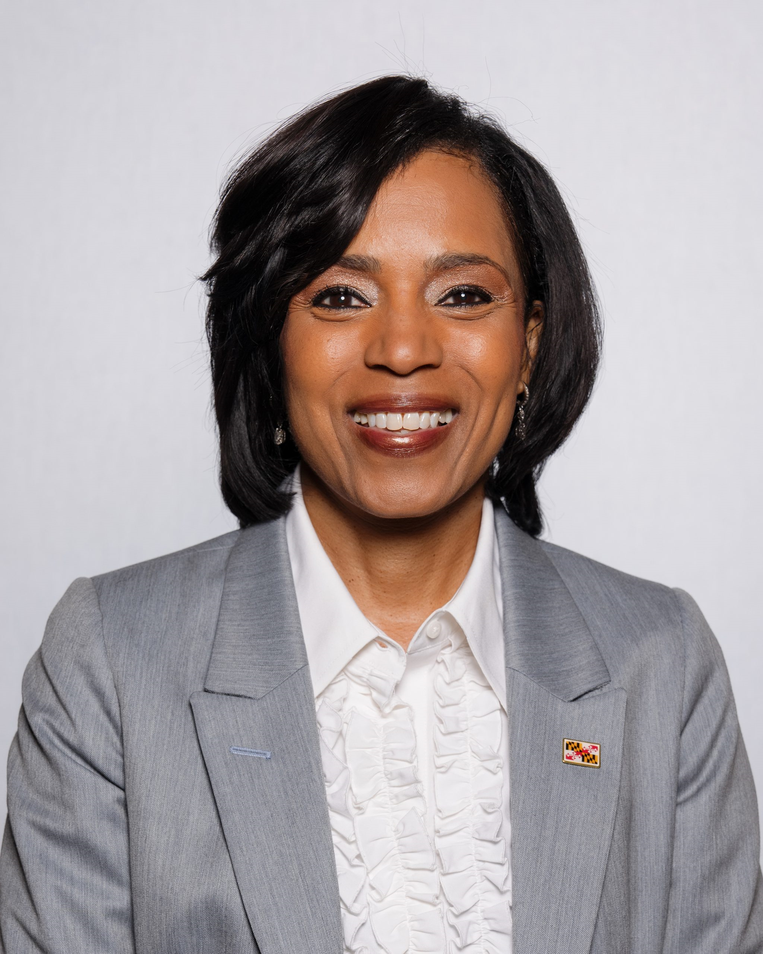
Angela Alsobrooks is a lifelong Marylander who was elected to the United States Senate in 2024. Her north star has always been the lesson her great grandmother taught her — that we all have a responsibility to get off the sidelines, to go farther and do better.
She has spent most of her life in public service, championing working families and fighting for safer communities. She believes that children shouldn’t have to live on the margins but instead, be able to pursue their wildest dreams. That means centering policies that elevate working families and provide every Marylander with economic pathways to wealth.

After graduating from Duke University and the University of Maryland School of Law, she worked as a law clerk in the Howard County Circuit Court, and later the Baltimore City Circuit Court. She went on to become the first full-time Assistant State’s Attorney to handle domestic violence cases in Prince George’s County. After holding roles in county government, Angela made history as the youngest and first woman to be elected Prince George’s County State’s Attorney.

As the Chief Law Enforcement Officer, Angela fought every day to create safer communities. During her tenure, violent crime fell by 50 percent. In 2018, Angela was elected Prince George’s County Executive. She honed in on increasing economic opportunity in the County, and within two years, she became one of the top job creators in the entire state.

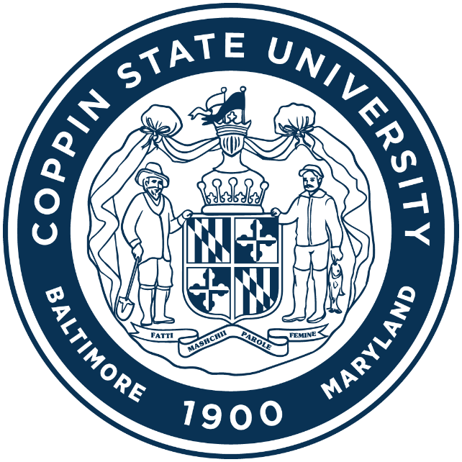

Commencement Decorum and Courtesy

Commencement ceremonies are held to acknowledge the culmination of one’s years of rigorous study. Although it is a celebration, it is a formal academic ceremony. The celebration of this academic milestone is often done with pomp, pageantry, and ritual. The Coppin family realizes this is a joyous occasion, but we ask that the dignity of the occasion not be devalued. Please respect the ceremony, the graduates, and others by adhering to the following:
- silence or disable cellular phones and other electronic devices
- avoid loud conversations
- limit unnecessary movement
- refrain from leaving your seats to take photographs of the graduates

- abstain from disruptive or inappropriate behavior
- remain silent during the announcement of the graduates’ names
- do not exit the field until ALL candidates have had their opportunity to cross the stage; remain seated
- do not block aisles or passageways
- do not use horns or noisemakers
- only representatives of the press or photographers authorized by the University are permitted to take photographs from the stage or ramps

Commencement Exercise
Friday, May 22, 2026
Processional
Pomp and Circumstance | Sir Edward Elgar
Ceremony Opening Grand Marshal, Blessing Diala-Ogamba, Ph.D.
Professor & Chair, Humanities Department

Presentation of Colors Coppin State University Army R.O.T.C. Color Guard
The Star-Spangled Banner Sung by Alana Younger (’26)
Lift Every Voice and Sing Sung by Praise Alayode (’26)
Welcome Anthony L. Jenkins, Ph.D.
President

Greetings The Honorable Wes Moore Governor of Maryland
Video
Tisha Edwards
University System of Maryland Board of Regents
John Hudgins, Ph.D.
President, Faculty Senate
Karis R. Joyner
President, Student Government Association
Introduction of Speaker President Jenkins
Commencement Address Senator Angela Alsobrooks
Presentation of Candidates for Degrees Chanta M. Haywood, Ph.D.
Provost and Vice-President for Academic Affairs
Recognition of Honors Provost Haywood
Greetings from the Coppin State University National Alumni Association Kevin A. Carr (’06)
Presidential Tribute and Closing Remarks President Jenkins
Hail to Thee Coppin Miles W. Connor, Alana Younger (’26)
Recessional
The War March of Priests | Felix Mendelssohn, arr.
Audience: Please Remain Seated Until Recessional Has Ended.

School of Graduate Studies and Research
CANDIDATES FOR DOCTOR OF NURSING PRACTICE DEGREE

Oluwaseun Adeniji, BSN, RN
B.S., Coppin State University, 2022
Nursing
Program: Bachelor of Science in Nursing to Doctor of Nursing Practice (BSN to DNP)
Project Title: Implementation of a Health Awareness Campaign Targeting Alcohol-Related Risky Sexual Behaviors Among Students: A Health Promotion Initiative

Danielle Jacqueline Artis, MSN, RN, CPN
B.S., University of Delaware, 2001
Nursing
M.S., Catholic University of America, 2010
Nursing
Program: Post Masters Doctor of Nursing Practice (DNP)
Project Title: Building Resilience in Newly Licensed Nurses: Insights and Recommendations for a Nurse Residency Program

Amber Vaughan, BSN, RN
B.S., Coppin State University, 2022
Nursing
Program: Post Masters Doctor of Nursing Practice (DNP)
Project Title: Investigation of the Knowledge of Hypertension and Medication Compliance Among African American Men Aged 18- 60 in a Faith-Based Setting

CANDIDATES FOR MASTER’S DEGREE

Master of Education in Contemporary Educational Leadership
Andrea Rosemarie Blagrove
B.S., Coppin State University, 2002
Applied Psychology

Latheena S. Galloway
B. S., Grand Canyon University, 2022
Education Studies

Master of Science in Addictions Counseling
Jazzmin Funnie-Penn
B.S., Pennsylvania State University, 2020
Psychology

Robert Leroy Graham
B.S., Coppin State University, 2021
Applied Psychology

Timothy Walker
B.A., University of Baltimore, 2018
Simulation and Digital Entertainment

Master of Science in Adult and Continuing Education
Latifa Ali
B.S., Coppin State University, 2023
Sport Management

Halutie Hor
B.S., Coppin State University, 2024
Sport Management

Marnae Torbit
B.S., Coppin State University, 2021
Early Childhood Education

Marisstella Vismale
B.S., Coppin State University, 1987
English

Master of Science in Applied Molecular Biology and Biochemistry
Adewale Adeleke
B.S., University of Agriculture Abeokuta, 2021
Chemistry

Muyang A.I. Chunga
B.S., Coppin State University, 2024
Biology & Life Sciences

Christian J. Stevens
B.S., Coppin State University, 2023
Biology & Life Sciences

Master of Science in Clinical Mental Health Counseling Rehabilitation
Kofi Appiah
B.S., Howard University, 2017
Psychology

Dawanda Boardley
B.S., Drexel University, 2023
Behavioral Health Counseling

Janelle Rochelle Dawkins
B.S., Salisbury University, 2006
Biology
M.A., Liberty University, 2013
Management and Leadership

Jamilah Arisa El-Amin
B.S., Coppin State University, 2021
Applied Psychology

Deborah Godfrey
B.A., Clark Atlanta University, 2023
Psychology

Jesse Ivory Green
B.S., North Carolina Central University, 2022
Psychology

Tiara Harris
B.A., South Carolina State University, 2009
Sociology
M.B.A., Columbia Southern University, 2020
Business Administration

Brianna Hitchcock
B.A., Goucher College, 2023
Psychology

Judaea Moore
B.S., Coppin State University, 2021
Health Information Management

Bethany Patara Peters
B.S., Frostburg State University, 2017
Sociology

Dawn A. Roberts
B.S., Sojourner Douglass College, 2012
Biotechnology

Alanna D. Simmons
B.B.A., Strayer University, 2022
Business Administration

Mahisha Smith
B.A., University of Baltimore, 2022
Arts Production Management

Sh'vone D. Smith
B.S., Coppin State University, 2023
Applied Psychology

Siarra Washington
B.S., Morgan State University, 2023
Psychology

Sherria D. Young-Smith
B.A., Sojourner Douglass College, 2007
Human Services
M.S., University of Baltimore, 2011
Human Services Administration

Master of Science in Criminal Justice and Law Enforcement
Chad Andrews-Fulton
B.S., Coppin State University, 2024
Interdisciplinary Studies

Jarrett Javier Gentles
B.S., Coppin State University, 2024
Interdisciplinary Studies

Jeff Hammond
B.S., Coppin State University, 2024
Social Science

Boanerges Kabeya Kalumbu Kabengele
B.A., University of Kinshasa, 2004
Demography

Gilbert E. McCoy, Jr.
B.S., Coppin State University, 2022
Criminal Justice

Charia A. Roberts
B.S., Coppin State University, 2024
Criminal Justice

Patricia Ann Smith
B.S., Coppin State University, 2009
Criminal Justice

TaKenya L. Stafford
B.S., Coppin State University, 2024
Criminal Justice

Syisha Walker
B.S., Wilberforce University, 2019
Social Work/Political Science

Master of Science in Human Services Administration
Maceo Glenn Boyce
B.S., Coppin State University, 2019
Applied Psychology

Ronald Fields
B.S., Coppin State University, 2011
Management Science

Tijuana O. Johnson
B.S., Coppin State University, 2016
Management

Lisa Moore
B.S., Coppin State University, 2004
Applied Psychology

Tanera Rochelle Parker
B.S., Coppin State University, 2024
Applied Psychology

Master of Science in Nursing
Adedoyin Victoria Akingbade
B.S., Coppin State University, 2021
Nursing

Master of Science in Polymer and Materials Sciences

Brittany N. Henly
B.S., Coppin State University, 2022
Chemistry

Keturah Faith Lynn
B.S., North Carolina State University
2020
Polymer and Color Chemistry

Pedro Jose Marte-Ortiz
B. S., Inter American University of Puerto Rico, 2014
Biology

Carolina B. Pellicier-Rodriguez
B.S., Inter American University of Puerto Rico, 2015
Biology

Curtis B. Williams
B.S., Coppin State University, 2015
Chemistry

Master of Science in Special Education
Angela Randolph
B.S., Coppin State University, 2018
Criminal Justice
College of Arts & Sciences and Education

CANDIDATES FOR BACCALAUREATE DEGREES

Biology & Life Sciences
Alexis J. Ausberry-Brooks
Tiwalola Adebola Balogun
Ahzhalon Monet Coleman
Jordan Coleman, Cum Laude
Anna A. Daramola, Summa Cum Laude
Ketsia-EL Chou Ekoko
Andrea V. Serrano Mercado, Magna Cum Laude
Jimetochukwu Solomon, Summa Cum Laude
Nahshon J. Thompson

Computer Science
Ulugbek Abdurakhmonov, Summa Cum Laude
Adebayo Martins Adeleye
Praise Jesujoba Alayode, Magna Cum Laude
TiVonna R. Allen
Jason Bandoh
Latia Andrea Carter, Cum Laude
Md. Abu Bakar Siddik Mishkat, Summa Cum Laude
Karon Terrell Nipper, Summa Cum Laude
Zayed Mohammed Uddin, Summa Cum Laude

Dance
Jayla Andrea-Chanae Matthews
Ericka Smith

Early Childhood Education
Starr Moore Farrell
Aryn Elisabeth Wilson, Magna Cum Laude

Early Childhood Education – Human Development
Heba Abdulmoneam Alhashim, Magna Cum Laude
Sierra Alston, Summa Cum Laude
Shantrice Sheree’ Bazemore, Summa Cum Laude
Chyna Enisha Bowie
Niesha Nicole Carr
Nicole Domonique Clark, Summa Cum Laude
Wakitha D. Collins, Magna Cum Laude
Ilona Druzynska, Summa Cum Laude
Egypt Hawkins
Lakisha Renee Hicks Cum Laude
Laura Ann O'Bannon
Shwanquana Owens, Summa Cum Laude
Jayla Rosier, Magna Cum Laude
Sabrina Leonora Scott-Cunningham
Jennie Wiggins, Magna Cum Laude

Elementary Education
Erica Hosein, Cum Laude
Jayla M. McCullough

English
Ivonna Levette Hoskins, Magna Cum Laude
London Rochelle, Cum Laude

History
Monica Greene, Cum Laude

Mathematics
Praise Jesujoba Alayode, Magna Cum Laude

Special Education
Jaryn Barbour, Summa Cum Laude
Shanae Bond, Summa Cum Laude
Alicia Marie Hewlett, Cum Laude
K'yeona Winston, Magna Cum Laude

Urban Arts
Tori Lanai Carlisle, Magna Cum Laude
Larry Maxwell Gill, Magna Cum Laude
Ilyawen Iman Ishii, Summa Cum Laude
Tracie Jiggetts

College of Behavioral and Social Sciences
CANDIDATES FOR BACCALAUREATE DEGREES
Applied Psychology
Nedrat Alassani
Stephan Malakhai Armstrong
Lanaya Bracey
Derek Basil Brooks
Aliya Brown
Karrissa Kayli Brown
Elijah Timothy Charlot
Eunice Fadjoh
Keara Alece Gordon
Aniyah Haley
Nykera Jatae Hall
Kashiah Y. Holden
Shaniya Hoxter
Sheldon Joseph King
Zaria Niya Long
Danielle Ashley Martin
Cecilia McKenzie-Richardson
Shaniya Najee McNair
Janiera Jeanette Middleton

Ana Maria Pineda
Corey Sean Primus
LaBria Shannon
Courtney Turner
Benjamin Wright
Andrea Kayla Wright-Brown
Nykol Mychel Wynn
Lawerence Young

Criminal Justice
Justin Carr
Katherine Schuylernoelle Chisholm
Brooklyn Clay
Myla Amani Clemons
Brelyn Inece Cole
Nyzjae Evans
Elanda Trinity Henriques
Ashya Hill
Jordan Holland
Jordan Jackson

Braggil Jones
Jordynn Logan
Jaelyn Lyles
Tatyana S. McEwen
Fatima Zarah Muhammed
Azul Pilahg
Janae Reid
Terrian Jamia Spence
Sabree Warren
Kishay Shatera Wilson

Interdisciplinary Studies
Kiya Adams
Idayat Adetoro
Jamie Denise Benjamin Magna Cum Laude
Patrice Burris
Sydney Burris
Jordan Carrington
Shiloh Cumber
Taylor Dames
Chanell Renee DeVaughn
Julius Ellerbe
Ambrah English
Juanita Gray
Demariontay Hall
Bessie T. Haskins
Benedicta Kwartemaa
Jamal Lee
Chrisdon Sterlin Morgan
Khila Monique Morris
Hassan Perkins, Cum Laude
Demariya Devon Ragin
Abdul Razak, Cum Laude
Kalise M. Robinson
Madison Nicole Rucker
Cole Schlotterbeck
Michael Smalls
Ileana Patricia Sosa Lora
Charis Taylor-Whitley
Dija Thopmson
Amer Williams

Political Science
Khadija A. Ba
Gabriel Breckenridge, Cum Laude
Dijonee Dorothya Chester
Jarmar Johnathan Diggs
Tiffany Glover
Karis Rebecca Joyner
Moses E. Muldrow IV

Rehabilitation Services
Emmly Freeman, Cum Laude
Myles J. Johnson

Social Sciences
Fahad Hassan Abbasi
Ahmad Jeremiah Pearl
April Pitts
Marcus Jose Sanders
Kwabena O. Stephens
Sierra Taylor

Social Work
Kae'Lyn Imari Carroll, Magna Cum Laude Luis Enrique Casimiro, Summa Cum Laude
Jaelyn Lejuan Childs, Magna Cum Laude
Izabela Krystina Engel
Dominique Monique Fisher-Burch, Magna Cum Laude
Jessiah Flood, Cum Laude
Jasmyne Brittany Ford, Magna Cum Laude
Krystina Francis, Summa Cum Laude
Teena Carmen Gibson, Cum Laude
Kyshan Harrell- Henry, Magna Cum Laude
Alisha Marie Holland, Magna Cum Laude
Rosalind Yvette Holsey, Summa Cum Laude
Vanessa N. Ighodaro, Summa Cum Laude
Breyia L. Jeffries, Cum Laude
Jeanice Keyonka Jenkins
Tameake Sharon Jones, Summa Cum Laude
Lakeesha Kenney, Summa Cum Laude
Sierra S. Kite, Magna Cum Laude
Jordyn Miles, Summa Cum Laude
Jumara Kimberly Pinkney, Magna Cum Laude
Reggie Denard Rooks, Cum Laude
Nicole Smith
Latavia Raquel Taylor, Cum Laude
Ayreonna Denise Terry
Melanie M. Timmons, Summa Cum Laude

Sociology
Eric Jordan, Magna Cum Laude
Gregory Kareem Noble

Urban Studies
Cree Smith

College of Business
CANDIDATES FOR BACCALAUREATE DEGREES

Accounting
Khya Jenkins, Magna Cum Laude
Maria J. Joseph, Summa Cum Laude
Angel Christian Love, Summa Cum Laude
Kayla Smith
Alysia T. Williamson

Data Science
Anderson Haywood, Cum Laude

Entertainment Management
William Tonnessen
Courtlyn Williams

Management
Samuel Adekoya, Magna Cum Laude
Basir Allen
Jordan Baker, Cum Laude
Alexandra Brice
Taylor Aiyana Colston
Laila Renee Crawford
Katrina Freeman
Arnyia Jannice Hemphill, Cum Laude
Ra'Emaa Amen Hill
Carmen Howard, Cum Laude
Daniel Lee Huff, Summa Cum Laude
Rishi Jalota, Magna Cum Laude
Nakiya Joseph
Bernard Kingsborough III, Magna Cum Laude
Almaya Al Mansaray
Jaylon RaShawn McGhee-Robinson
Liam Alexander Murtaugh, Cum Laude
Sydni Reuben, Magna Cum Laude
Reagan Isaac Rivera
Camara Malaika Salmon

Frank Jerry Samuels
Shamika Smith, Cum Laude
Tanesha Rebecca Taylor, Summa Cum Laude
Keronja Walker
Alexia S. White

Management Information Systems
Khaleb Amir Byrd, Cum Laude
Virginia Campbell
Amara Doucoure, Magna Cum Laude
Brandon Nigel Gorham
Shantay A. Jackson
Jadyn Moaney
Rayona Ania Price
Bria Sedgwick, Summa Cum Laude
Emily Smith, Cum Laude
Jawan Taylor, Cum Laude
Calvin Lee Williams, Jr., Magna Cum Laude

Marketing
Alison Azarak Quebengco, Magna Cum Laude
Kaylen Bre'el Carroll, Cum Laude
Pranav Swamy Sundar, Summa Cum Laude
Bryce Davis Thompson, Cum Laude

Sports Management
Luke Corcoran, Cum Laude
Joshua Jackson
Devin Jordan
Khamani Lanae Opher, Summa Cum Laude
Woizero Gabrielle Richards
Tracey Riley
Mekhi Slaughter, Magna Cum Laude
Brooklyn Tapusoa, Cum Laude
Paris Jamal Young

College of Health Professions
CANDIDATES FOR BACCALAUREATE DEGREES

Health Information Management
Olajumoke Aderibigbe
Khadiza Akter
Sajina Khadka, Summa Cum Laude
Diamond Smith
Courtney M. Thomas

Health Sciences
Catherine Trumata Addey, Magna Cum Laude
Ayisat Adigun
Tamara Beverly Rice
Janiya Markia Camphor, Cum Laude
Richard Oladipo Fadipe

Amiri Goode
Markia Jacks
Enya Jackson
Noah Jones
Nyasia Doreen Jones
Shantel Lee
Ajah Monae Logan
Aliyah Jeyone Muhammad
Desmia Payne
Cheniya Courtney Perkins, Cum Laude
Tamia Smith
Destony A. Stamper
Breonna K. Taylor, Cum Laude
Mia Thomas
Tomarray Miracle Walton

Nursing
Janet Abdulai, Cum Laude
Bushra A. Abdul-Jabbar
Blessing Asante, Cum Laude
Christina C. Bell, Summa Cum Laude
Brianna Nicole Benton
Nitiya R. Brown
Khalesha Gabrelle Carty
Lucy O. Eke, Magna Cum Laude
Denae Elliott
Chavonne Epps
Cherry Rose Espiritu
Marsha Marvalyn Harrison, Cum Laude
Khijha Howard
Ciara Joseph
Jashawna T. McCullough
Arden Lania Mitchell
Robert Garry Morton
Silvana T. Peraza, Cum Laude
Imani Pittman
Miyah Denise Pollard
Bukola O. Popoola, Summa Cum Laude
Auyden J. Reddick, Cum Laude
Ikeyshia Reynolds
Peggy Laiwan Ringgold
Amaya Serrano, Cum Laude
Erwin Nuelan Siao
Panyaphon Tawinittiphon, Magna Cum Laude
Ma'Rynn R'Shon Thomason
Ronalee J. Wright
Alana Lizette Younger, Magna Cum Laude

Honors and Recognitions

Honors
Consideration for honors for any Coppin undergraduate student (transfer or non-transfer) will be determined by the cumulative grade point average of all college work entered into the undergraduate’s permanent academic record, regardless of where the work was pursued. Any student graduating with honors shall have earned not more than one grade of “D” or “F.” Academic clemency for purposes of honors shall apply to students who have not attended any college or university for a period of ten years or more immediately prior to the current period of attendance at Coppin.

Latin Honors are determined as follows:
Summa Cum Laude – accumulative average of 3.75 or higher
Magna Cum Laude – accumulative average of 3.50 through 3.74
Cum Laude – accumulative average of 3.25 to 3.49

Circulus Scholarum Society criterion for induction is:
Graduate Student – A student who has maintained a 3.8 average as a full-time student, enrolled in at least nine credits hours per semester.

Undergraduate – A student who has maintained a 3.50 average for six semesters as a full-time student, two semesters of which must be junior year.

Distinguished Eagle Award is awarded to seniors who have earned the highest grade point averages in their majors, 3.5 minimum, for Fall 2025 and Spring 2026.

Honors listed in this program have been computed from the end of the candidate’s last term of enrollment. A final computation will be conducted after all final grades have been submitted for Spring 2026 candidates.

Summa Cum Laude
Ulugbek Abdurakhmonov
Sierra Alston
Jaryn Barbour
Shantrice Sheree’ Bazemore
Christina C. Bell
Shanae Bond
Luis Enrique Casimiro
Nicole Domonique Clark
Anna A. Daramola
Ilona Druzynska
Krystina Francis
Rosalind Yvette Holsey
Daniel Lee Huff
Vanessa N. Ighodaro
Ilyawen Iman Ishii
Tameake Sharon Jones
Maria J. Joseph
Lakeesha Kenney
Sajina Khadka

Angel Christian Love
Jordyn Miles
Md. Abu Bakar Siddik Mishkat
Karon Terrell Nipper
Khamani Lanae Opher
Shwanquana Owens
Bukola O. Popoola
Bria Sedgwick
Jimetochukwu Solomon
Pranav Swamy Sundar
Tanesha Rebecca Taylor
Melanie M. Timmons
Zayed Mohammed Uddin

Magna Cum Laude
Catherine Trumata Addey
Samuel Adekoya
Praise Jesujoba Alayode

Heba Abdulmoneam Alhashim
Alison Azarak Quebengco
Jamie Denise Benjamin
Tori Lanai Carlisle
Kae'Lyn Imari Carroll
Jaelyn Lejuan Childs
Wakitha D. Collins
Amara Doucoure
Lucy O. Eke
Dominique Monique Fisher-Burch
Jasmyne Brittany Ford
Larry Maxwell Gill
Kyshan Harrell- Henry
Alisha Marie Holland
Ivonna Levette Hoskins
Rishi Jalota
Khya Jenkins
Eric Jordan
Bernard Kingsborough III
Sierra S. Kite
Jumara Kimberly Perry
Sydni Reuben
Jayla Rosier
Andrea V. Serrano Mercado
Mekhi Slaughter
Panyaphon Tawinittiphon
Jennie Wiggins
Calvin Lee Williams, Jr.
Aryn Elisabeth Wilson
K'yeona Winston
Alana Lizette Younger

Cum Laude
Janet Abdulai
Blessing Asante
Jordan Baker
Gabriel Breckenridge
Khaleb Amir Byrd
Janiya Markia Camphor
Kaylen Bre'el Carroll
Latia Andrea Carter
Jordan Coleman
Luke Corcoran
Jessiah Flood
Emmly Freeman
Teena Carmen Gibson
Monica Greene
Marsha Marvalyn Harrison
Anderson Haywood
Arnyia Jannice Hemphill
Alicia Marie Hewlett

Lakisha Renee Hicks
Erica Hosein
Carmen Howard
Breyia L. Jeffries
Liam Alexander Murtaugh
Silvana T. Peraza
Cheniya Courtney Perkins
Hassan Perkins
Abdul Razak
Auyden J. Reddick
London Rochelle
Reggie Denard Rooks
Amaya Serrano
Shamika Smith
Emily Smith
Brooklyn Tapusoa
Latavia Raquel Taylor
Jawan Taylor
Breonna K. Taylor
Bryce Davis Thompson

Circulus Scholarum
Adewale Adeleke
Dawanda Boardley
Jamilah Arisa El-Amin
Brianna Hitchcock
Charia A. Roberts
Mahisha D. Smith
TaKenya L. Stafford
Siarra Washington

Distinguished Eagle Award Recipients
Seniors who have earned the highest GPA in their majors, 3.5 minimum

College of Arts & Sciences And Education
Sierra Alston
Shantrice Sheree’Bazemore
Shanae Bond
Nicole Domonique Clark
Erica Hosein
Ivonna Levette Hoskins
Ilyawen Iman Ishii
Karon Terrell Nipper
London Rochelle
Jimetochukwu Solomon
Zayed Mohammed Uddin
Aryn Elisabeth Wilson
K'yeona Winston

College of Business
Amara Doucoure
Carmen Howard
Daniel Lee Huff
Angel Christian Love
Khamani Lanae Opher
Bria Sedgwick
Mekhi Slaughter
Pranav Swamy Sundar
Tanesha Rebecca Taylor

College of Health Professions
Catherine Trumata Addey
Sajina Khadka
Breonna K. Taylor
Alana Lizette Younger

College of Behavioral and Social Sciences
Karrissa Kayli Brown
Eunice Fadjoh
Krystina Francis
Emmly Freeman
Juanita Gray
Rosalind Holsey
Eric Jordan
Karis Joyner
Azul Pilahg
Abdul Razak
Cree Smith
Sierra Taylor

Four-Year Honors Program
Alexis J. Ausberry-Brooks
Janiya Markia Camphor
Khalesha Gabrelle Carty
Jordan Coleman
Eunice Fadjoh
Nykera Jatae Hall
Alisha Marie Holland
Angel Christian Love
Karon Terrell Nipper
Silvana T. Peraza
Corey Sean Primus
Andrea Kayla Wright-Brown

Upper Division Honors Program
Ulugbek Abdurakhmonov
Myla Amani Clemons
Amara Doucoure
Anderson Haywood

Daniel Lee Huff
Md. Abu Bakar Siddik Mishkat
Zayed Mohammed Uddin

Strada Scholar Graduate
Janiya Markia Camphor

HONOR SOCIETIES
Alpha Psi Omega National Theatre Honor Society
Larry Maxwell Gill

Beta Kappa Chi
Tiwalola Adebola Balogun

Chi Sigma Iota Rho Alpha Eta
Clinical Mental Health Counseling
Dawanda Boardley
Janelle Rochelle Dawkins
Jamilah Arisa El-Amin
Deborah Godfrey
Jesse Ivory Green
Tiara Harris
Bethany Patara Peters
Dawn A. Roberts
Sh'vone Smith
Siarra Washington
Sherria D. Young-Smith

Delta Mu Delta
International Honor Society
College of Business
Alison Azarak Quebengco
Alexandra Brice
Khaleb Amir Byrd
Anderson Haywood
Arnyia Jannice Hemphill
Daniel Lee Huff
Shantay A. Jackson
Rishi Jalota
Mariah J. Joseph
Angel Christian Love
Jaylon RaShawn McGhee-Robinson
Liam Alexander Murtaugh
Khamani Lanae Opher
Woizero Gabrielle Richards
Shamika Smith
Pranav Swamy Sundar
Brooklyn Tapusoa

Bryce Davis Thompson
Jawan Taylor
Calvin Lee Williams, Jr.

Mary Mahoney Honor Society Nursing
Blessing Asante
Christina C. Bell
Nitiya R. Brown
Lucy O. Eke
Bukola O. Popoola
Panyaphon Tawinittiphon
Alana Lizette Younger

Maxie Collier Scholars
Jaelyn Lejuan Childs
Myla Amani Clemons
Shiloh Cumber
Dominique Monique Fisher-Burch
Rosalind Yvette Holsey
Zaria Niya Long
Danielle Ashley Martin
Fatima Zarah Muhammed
Cheniya Courtney Perkins
LaBria Shannon
Tomarray Miracle Walton
Andrea Kayla Wright-Brown
Lawrence Young

Phi Alpha Social Work Honor Society
Theta Rho Chapter
Kae'Lyn Carroll
Luis Enrique Casimiro
Dominique Monique Fisher-Burch
Jasmyne Brittany Ford
Krystina Francis
Monica Greene
Rosalind Yvette Holsey
Vanessa N. Ighodaro
Tameaka Jones
Lakeesha Kenney
Jordyn Miles
Melanie M. Timmons

Pi Gamma Mu
International Honor Society for the Social Sciences
Fahad Hassan Abbasi
Karrissa Kayli Brown
Jarmar Jonathan Diggs
Eric Jordan
Karis Rebecca Joyner
April Pitts
Cree Smith
Sierra Taylor

Psi Chi, International Honor Society in Psychology
Jamilah Arisa El-Amin
Deborah Godfrey
Aniyah Haley
Kashiah Y. Holden
Shaniya Najee McNair
Judaea Moore
Dawn A. Roberts
Sh’vone Smith
Courtney Turner
Timothy Walker
Nykol Mychel Wynn
Sherria D. Young-Smith

Sigma Tau Delta
Ivonna Levette Hoskins

Tau Upsilon Alpha National Organization for Human Services Honor Society
Maceo Glenn Boyce
Tanera Rochelle Parker

Commencement Information
Academic Regalia
The current practice of wearing caps and gowns has been handed down from the Middle Ages when scholars in the monasteries wore habits characteristic of their respective orders. Each order had its own style and colors.
The Bachelor’s gown, which is worn closed, has long pointed sleeves. The Master’s gown is made with openings in the sleeves near the elbow for the arms to come through. The Doctor’s gown has full, bell-shaped sleeves with three horizontal bars stitched across the upper arm. The hood is long, full, rounded at the base and bordered with velvet.
The velvet color of the hood indicates the field of study in which the degree was granted.
Dark Blue Philosophy Purple Laws
Light Blue Education White Arts and Letters
Orange Engineering Drab Business Administration
Gold-Yellow Science Brown Fine Arts
Green Medicine Gold Psychology
Apricot Nursing Citron Social Work
Salmon Pink Public Health Scarlet Theology

The colors of the satin lining of the hood represent the degree-granting institution.
The Coppin Mace
The Coppin mace, a heavy medieval war club with a spiked or flanged metal head, was used to crush armor. In England, when a high official was taking office or opening his court and needed a bodyguard, the mace, a formidable weapon, was held ready to protect the person of the dignitary.
From sixteenth-century England and colonial days in America, the mace, an ornamental staff, has become a symbol of authority and is carried immediately preceding the president in processionals, recessionals, and other official academic ceremonies. Though it is not used in all school ceremonies, the mace is particularly prevalent in academic ceremonies of older, more prestigious colleges and universities on the east coast of the United States.
The mace borne today was donated to Coppin State College by the Class of 1986.
Alumni Induction Pledge of Allegiance
For all the inspiration Alma Mater has brought me through the years that are past, and for all the brightness that Alma Mater will shed along my path in the future, continuing to give direction and meaning to my life in order that I might help others find meaning in living and serving, I am grateful.
And for these gifts, I pledge everlasting loyalty, love, and devotion.
Always I shall be a faithful and active member of the Association of Alma Mater and shall do all within my power to support her plan, spread her name abroad, expand her membership, and keep her first among all organizations.

Coppin State University Leadership
Anthony L. Jenkins, Ph.D.
University President

Chanta M. Haywood, Ph.D.
Provost and Vice President for Academic Affairs

Derek Carter
Director of Athletics

Dionne N. Curbeam, Ed.D.
Vice President for Information Technology and Chief Information Officer

Stephen R. Danik
Vice President for Administration and Finance

Stephanie K. Hall
Chief Government and Legislative Affairs Officer

Joshua E. Humbert
Vice President for Institutional Advancement

Dorothy Parrish-Harris, J.D.
Co-Division Leader for Enrollment Management and Student Affairs

James Stewart, Ph.D.
Co-Division Leader for Enrollment Management and Student Affairs

Ann-Marie Waterman, Ph.D.
Chief of Staff

Academic Leadership

Mintesinot Jiru., Ph.D., Interim Dean, College of Arts & Sciences and Education

Beverly J. O’Bryant, Ph.D., Dean, College of Behavioral Health and Social Sciences

Sadie R. Gregory, Ph.D., Dean, College of Business

Joan S. Tilghman, Ph.D., Dean, College of Health Professions

Ronald C. Williams, D.B.A., Interim Dean, School of Graduate Studies and Research

University System of Maryland
Jay A. Perman, M.D., Chancellor, University System of Maryland

Board of Regents
Linda R. Gooden, Chair
Geoff J. Gonella, Vice-Chair
William T. “Bill” Wood, Treasurer
Andy Smarick, Secretary
Ellen R. Fish, Asst. Treasurer
Yvette Lewis, Asst. Secretary
Kevin Atticks, ex officio
Harry Coker, Jr., ex officio
Sherri N. Blount
Tisha Edwards
Michelle A. Gourdine, M.D.
Anwer Hasan
Robert Hur
Isiah (Ike) Leggett
Charles T. (Tom) McMillen
Michele Speaks
Dana B. Stebbins, Esq.
Dhruvak Mirani, Student Regent
Rayne Rivera-Forbes, Student Regent

Coppin State University Development Foundation Board
Alicia N. Ritchie, Esq. (‘01), Chair
Stephen H. Johnson, Esq. (’01), Secretary
Patricia D. Murray
Kimberly Y. Robinson, Esq.
John L. Walters
Debbie Bragg
Sadie R. Gregory, Ph.D.
Jemal Griffin (’96)
Sean Malone, Esq.
David Ralph
Ex-Officio
Anthony L. Jenkins, Ph.D., President, Coppin State University
Chanta M. Haywood, Ph.D., Provost and Vice President for Academic Affairs, Coppin State University
Joshua E. Humbert, Vice President for Institutional Advancement, Coppin State University
Stephen R. Danik, Vice President for Administration & Finance, Coppin State University

Campus Governance
John L. Hudgins, Ph.D., President, Faculty Senate
Mirma A. Johnson-Majors, Ed.D., President, Adjunct Faculty Senate
Sheila Chase, Chair, Staff Senate
Karis R. Joyner, President, Student Government Association

Marshals

Grand Marshal
Blessing Diala-Ogamba, Ph.D.

Marshals
Loretta Baryeh, Ph.D.
Mona Calhoun, Ph.D.
Angela Charlton, Ph.D.
Patience Ebuwei, D.B.A.
Lori Harvin, DNP
John Magness, Ph.D.
Sherida Morrison, MSOD
Jude Namanga, Ph.D.
Carlin Nelson, Ph.D.
Mercy Shenge, Ph.D.
James Stewart, Ph.D.
Aerian Tatum, Ph.D.
Claudia Thorne, Ph.D.
Janique Walker, Ph.D.
Denyce Watties-Daniels, DNP
Joshua Wilder, Ph.D.
Pierre Wright, Ph.D.
Min Zhang, Ph.D.

The Star Spangled Banner
by Francis Scott Key
(The first verse)
Oh, say, can you see, by the dawn’s early light,
What so proudly we hailed at the twilight’s last gleaming?
Whose broad stripes and bright stars, thru the perilous fight,
O’er the ramparts we watched, were so gallantly streaming?
And the rockets’ red glare, the bombs bursting in air,
Gave proof through the night that our flag was still there.
O say, does that star-spangled banner yet wave
O’er the land of the free and the home of the brave?

Lift Every Voice and Sing
by James Weldon Johnson
(The first verse)
Lift every voice and sing, till earth and Heaven ring,
Ring with the harmonies of liberty;
Let our rejoicing rise, high as the listening skies,
Let it resound loud as the rolling sea.
Sing a song full of the faith that the dark past has taught us,
Sing a song full of the hope that the present has brought us;
Facing the rising sun of our new day begun,
Let us march on till victory is won.

The Alma Mater
(“HAIL TO THEE, COPPIN”)
by Dr. Miles W. Connor
Hail to thee, Coppin, our alma mater true,
We raise our song to thee with hearts anew;
Thy name has been our pride,
Thy light has been our guide,
Leading us ever on
Through all the years.
Hail to thee, Coppin, our alma mater true,
Emblem of light and love, our gold and blue.
Here at thy shrine we bow,
Gladly to make our vow
That we shall always stand
Loyal to thee.

